Copy snapshot from one region to another

We priously created a instance and attach it volume that we created

Now we will create snapshot of that attached volume.

First, go to the ec2 nevigation bar elastic block store 🡪 volumes

Select the volume that we want to create a snapshot

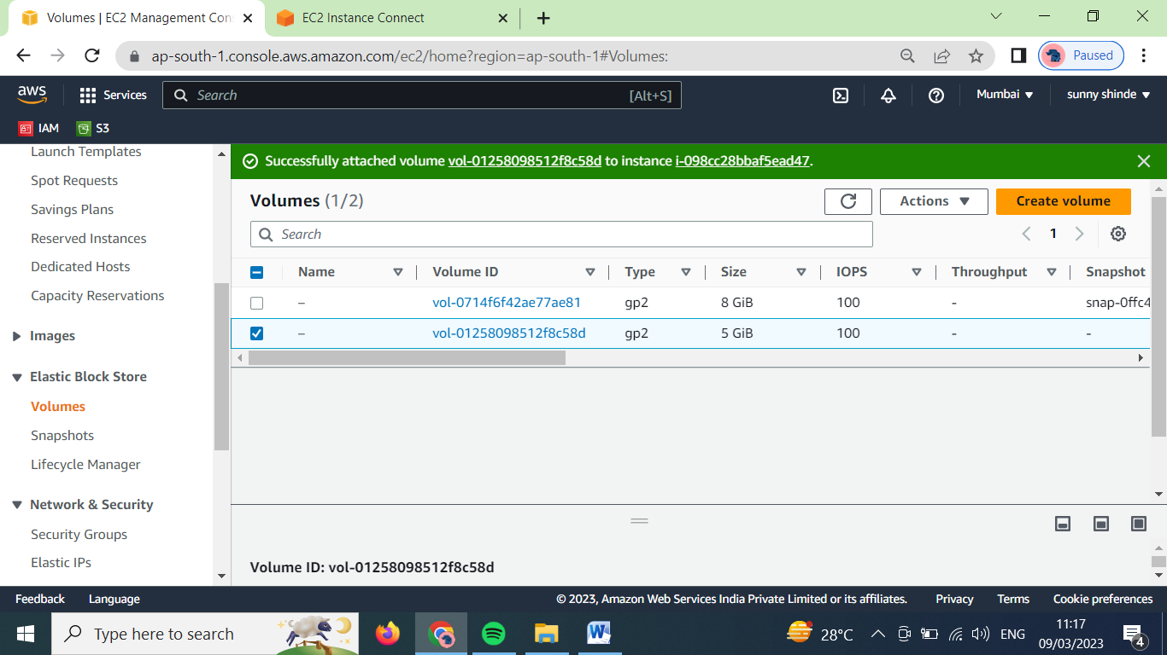

Click on actions 🡪 create snapshot

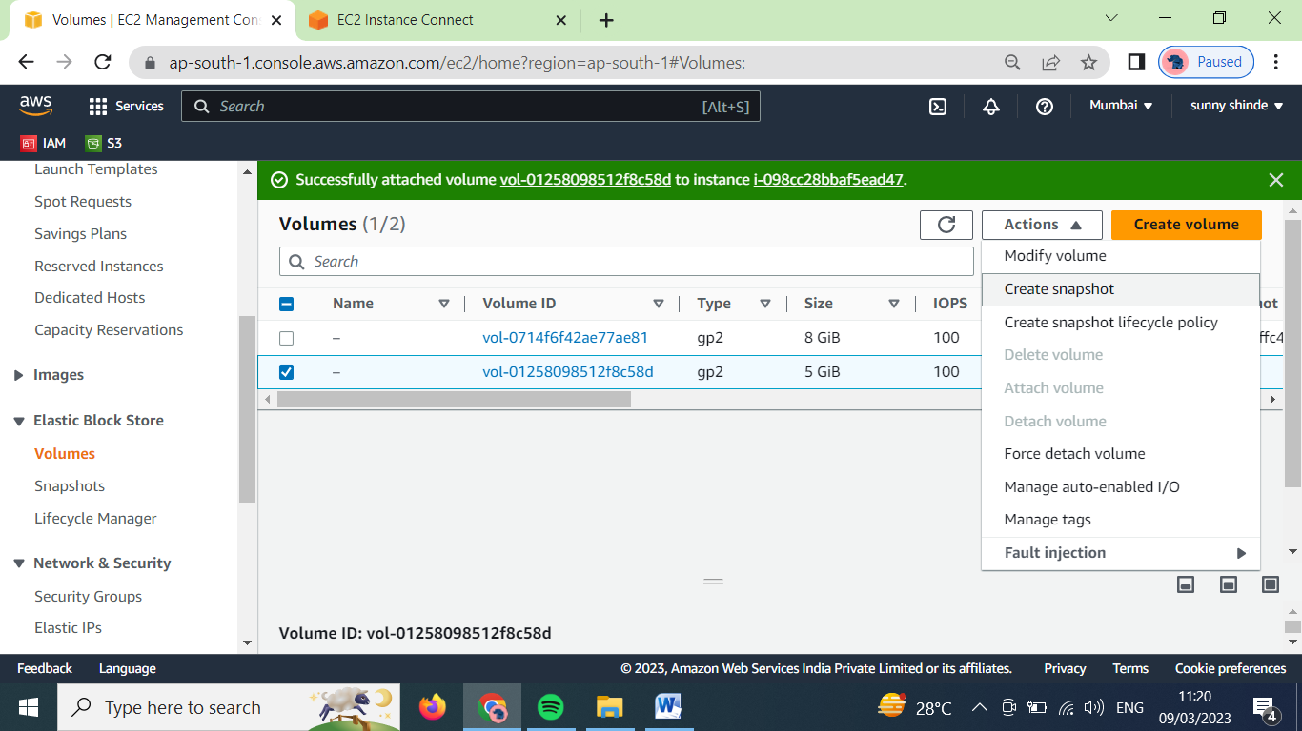

The following page will open

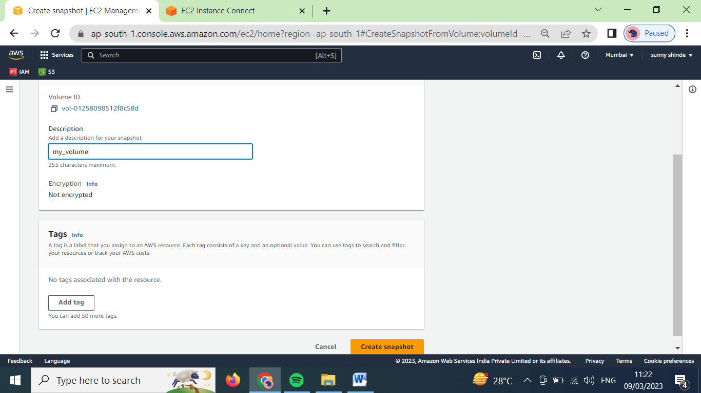

Give the description and click on create snapshot

Then notification will appear that the snapshot is created.

Go the navigation bar elastic block store 🡪 snapshot

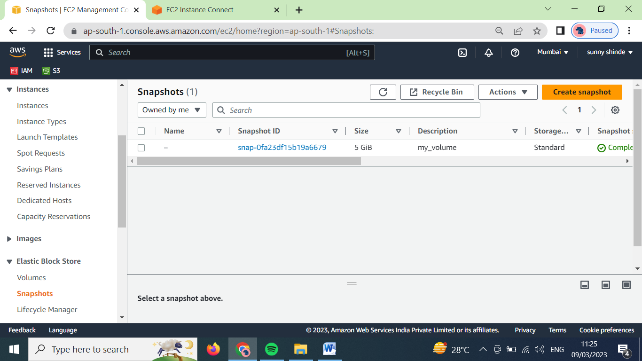

Here as we can see our snapshot has been created

Now select the snapshot, click on actions 🡪 copy snapshot

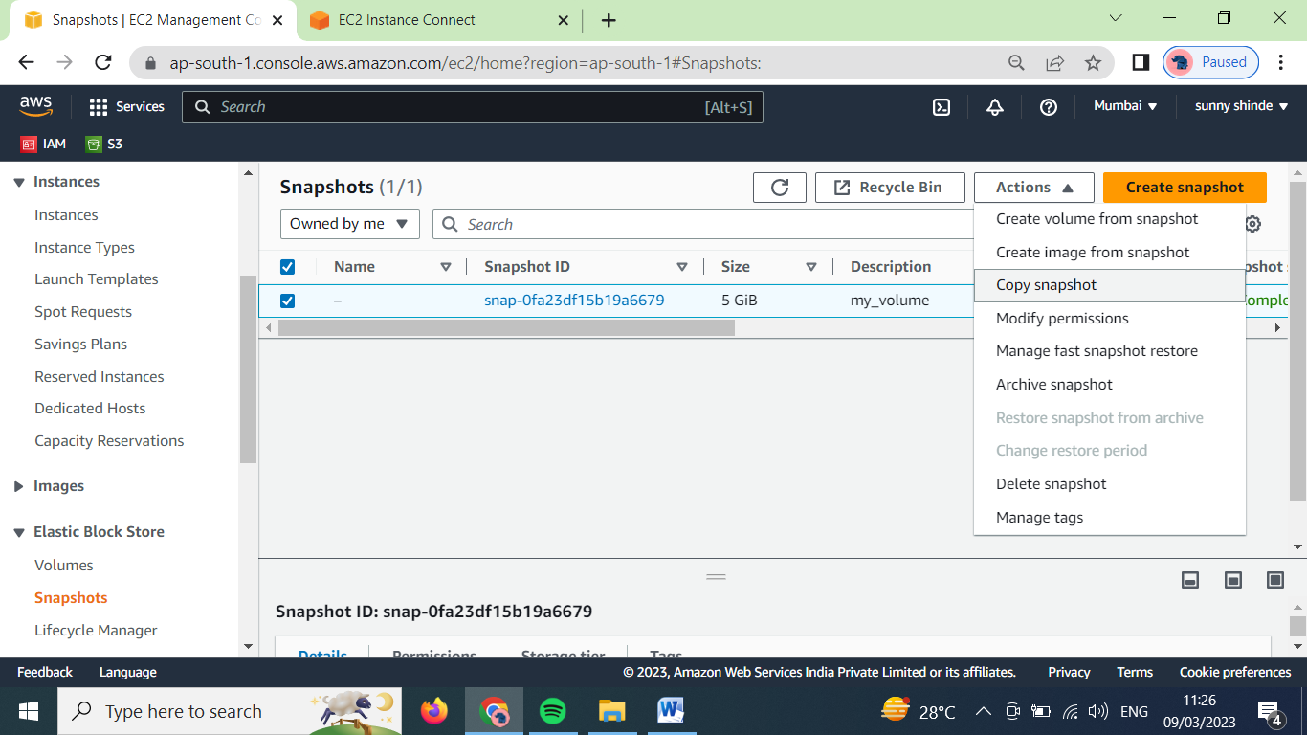

It will ask for destination region, now lets copy it to ohio region us-east-2. Click on copy snapshot

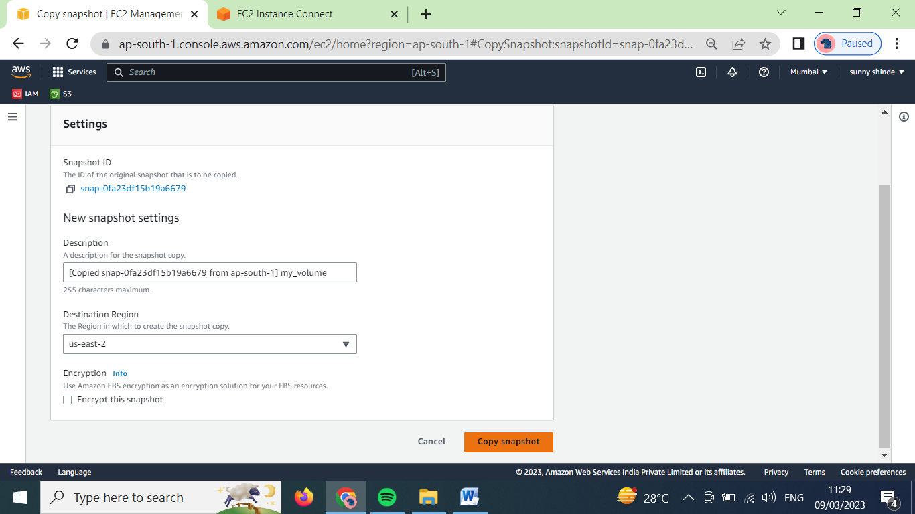

Now our snapshot will be copied in us-east-2 region

To verify that change the region to us-east-2 region

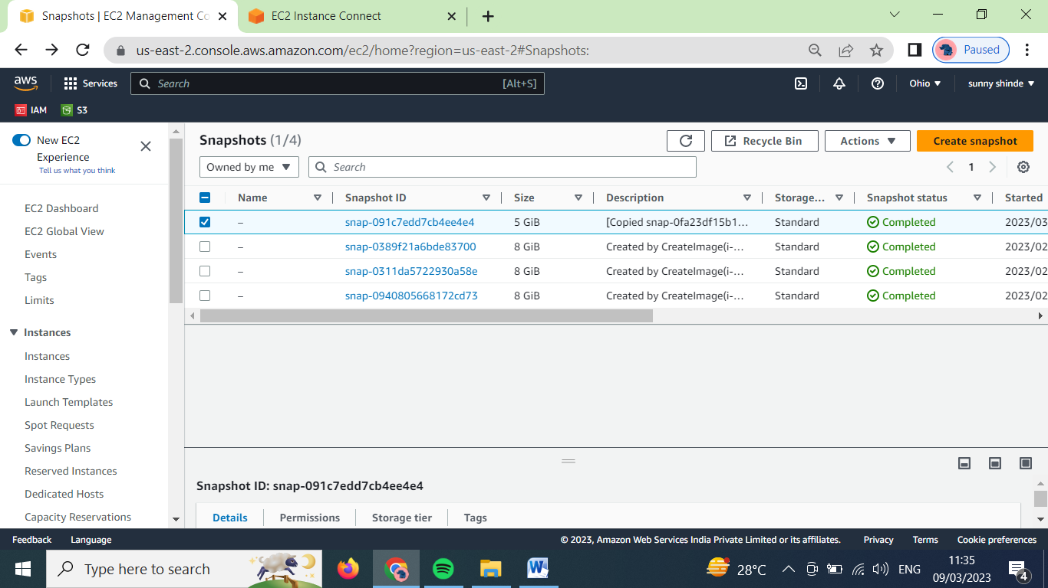

As we can see in above image, our snapshot is successfully copied in the ohio region.

Now lets share that snapshot which we created in another account

Now click on snapshot id

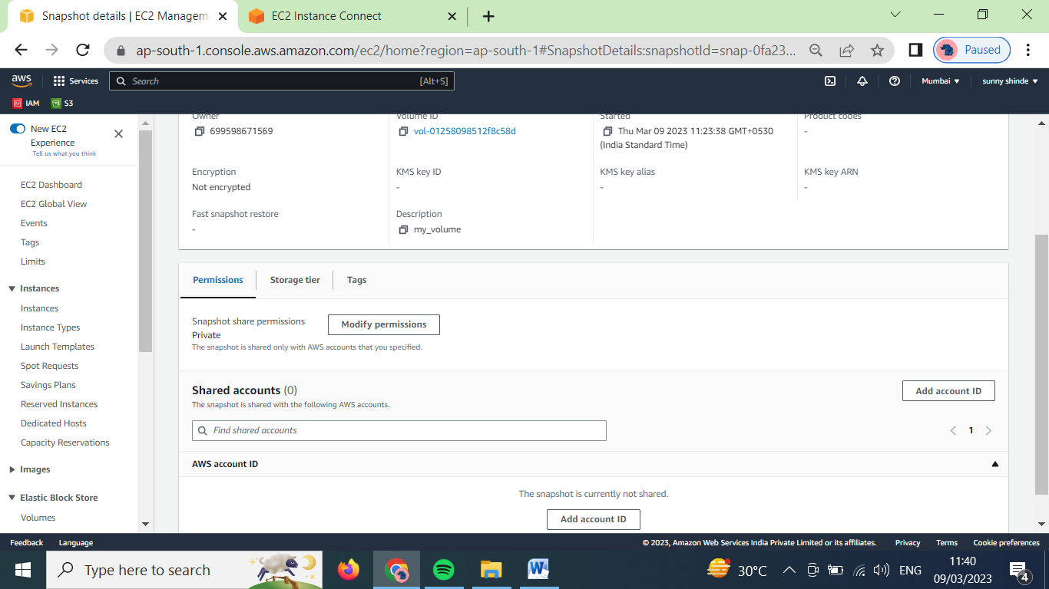

In shared accounts section click on add account ID

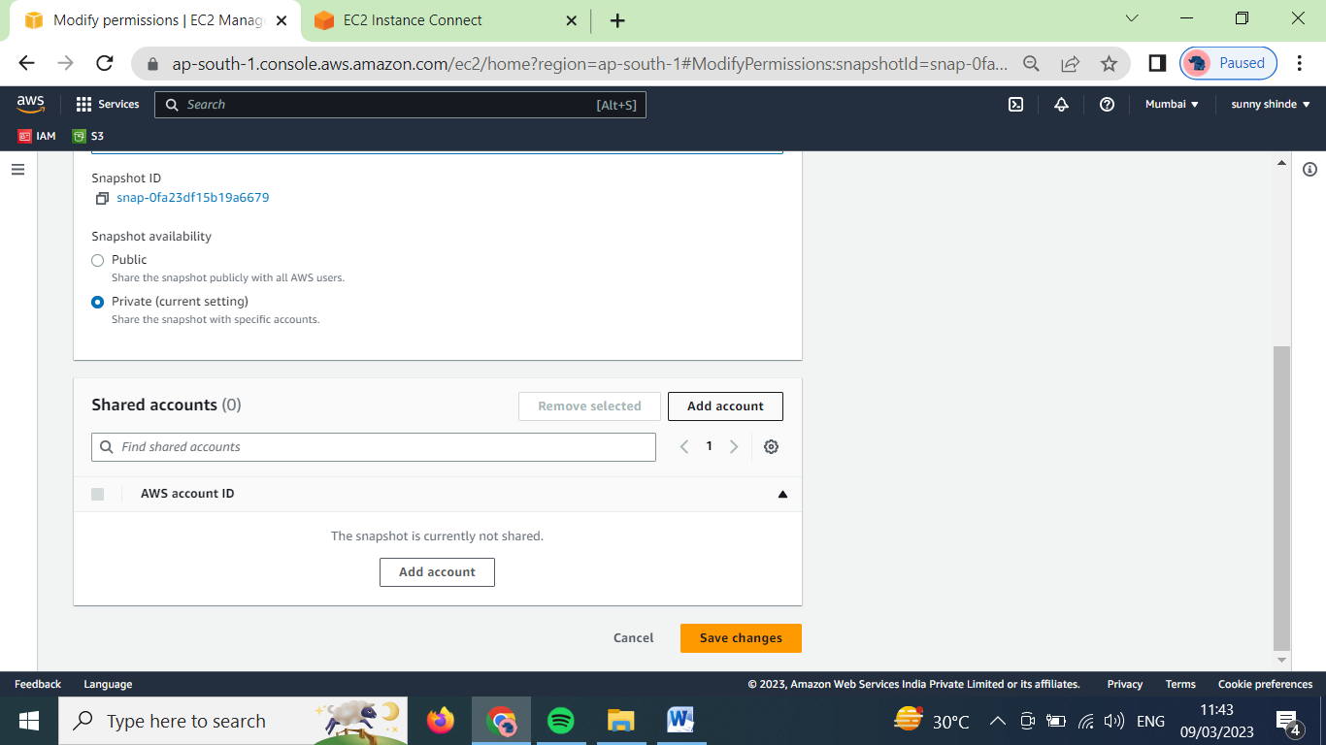

In above image we selected snapshot availabily to privet, because we want to share this image only to specific user. Then click on add account

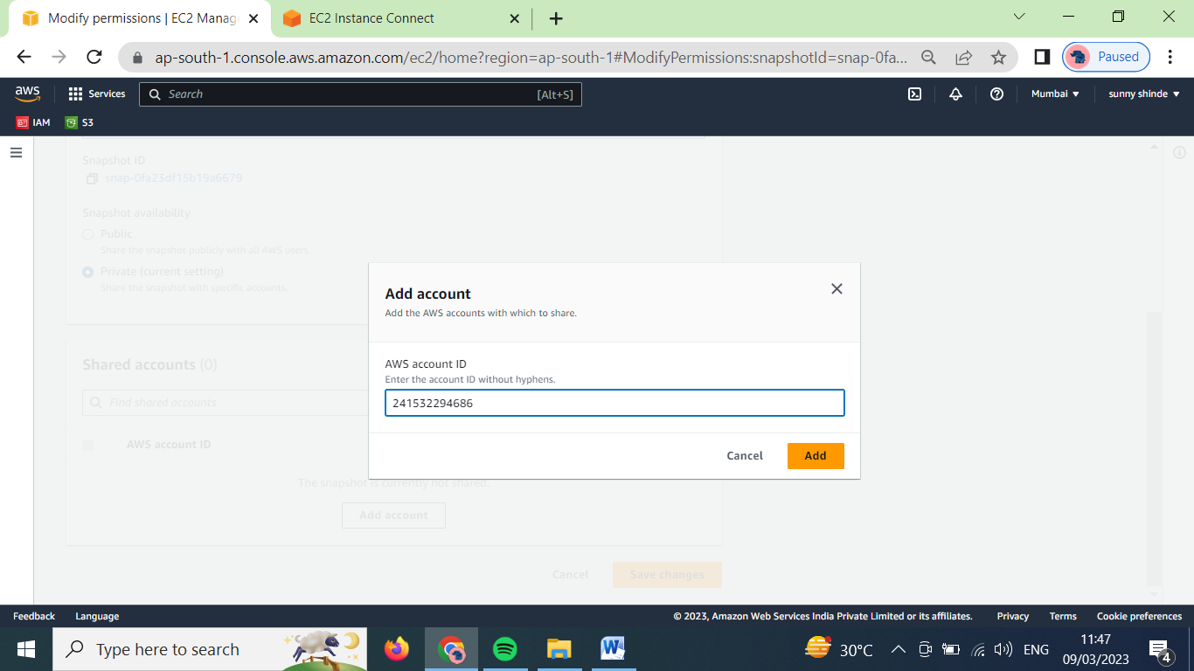

Type the account id that we want to share and click on add

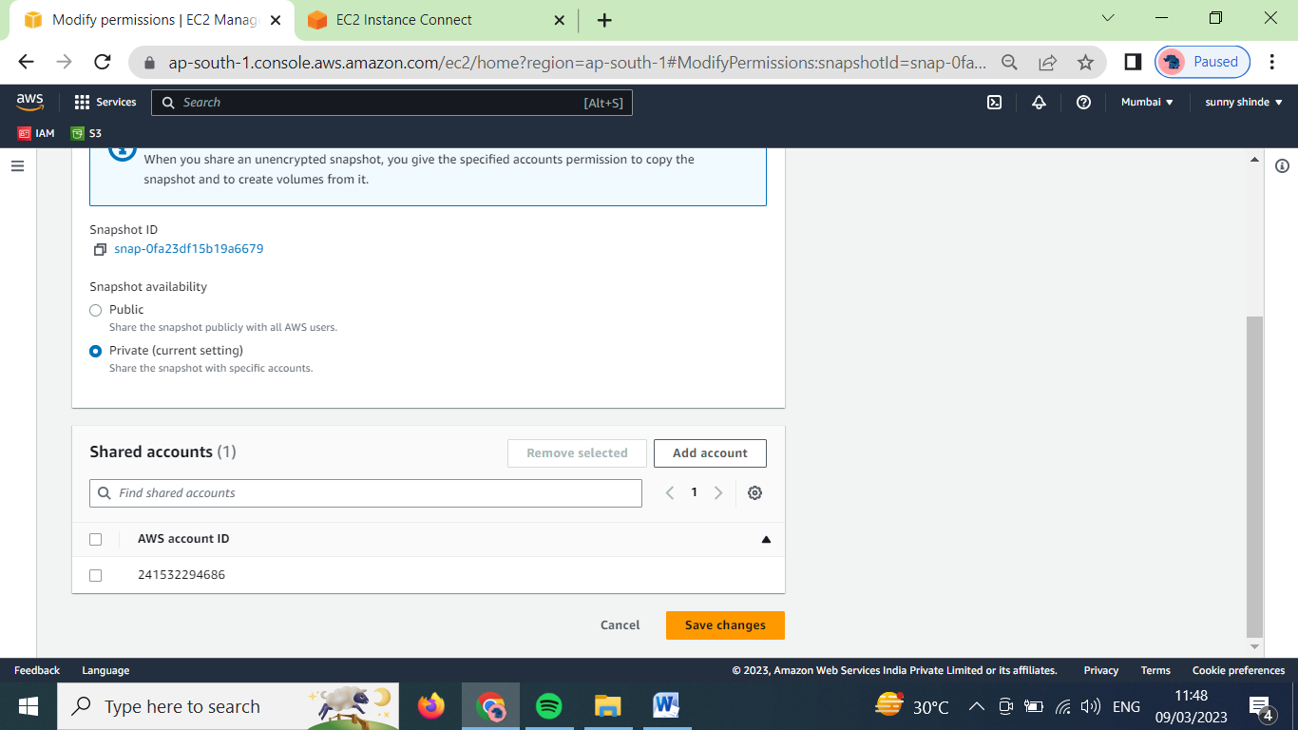

Click one save changes.

Now that our snapshot will be share in that account